Climate change – a handout for the People of India
The only relevant policy question about climate change is the effect of CO2. Our party has confirmed that CO2 has no observable effect on the climate.

The Earth started warming from around 1800 after the end of the Little Ice Age. The rather poorly correlated relationship between warming since 1800 and man-made CO2 emissions since 1950 is purely coincidental, not causal. Geological data also confirm that CO2 never caused climate change in the past - so it is impossible for it to cause such change today.
It is not necessary to have a proven alternative theory of the climate, for that is an ongoing matter for science to explore. Our party rejects attempts by UN organisations to impose the socialist model on the world in the guise of “climate change”. We remain committed to appropriate action against real pollutants and real environmental issues.

THERE IS NO EVIDENCE OF MAN-MADE CONTRIBUTION TO GLOBAL TEMPERATURES
IPCC’s data on temperature: The following diagram, from page 202 of IPCC's first report, shows that (a) natural causes make temperatures vary by as much as 6 degrees Celsius over frequent periods of time, and (b) variation over the past 6000 years has been nearly 2 degrees, with the Holocene maximum 6000 years ago and Medieval warm period 1200 year ago much warmer than 20th century warming.
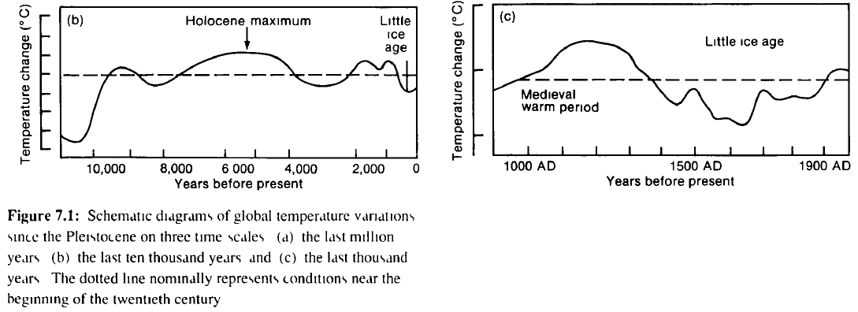
A similar diagram is found at Selley's Encylopedia of Geology 2005. This is the best science that we have.
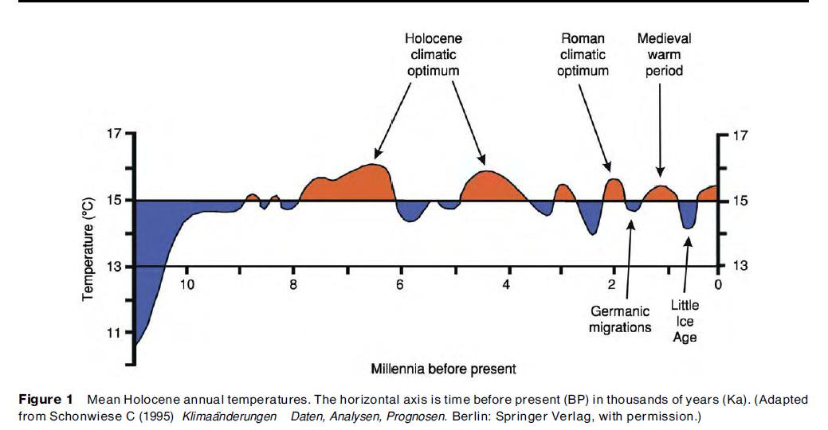
Our party rejects spurious attempts (e.g. by Michael Mann) to pervert geological science.
During the Little Ice Age, the Thames river in England froze over for many decades and markets were held on the river for many months in winter (painting below). Many other Little Ice Age paintings are linked here.
The world has started warming on its own (causes are not fully clear to science, yet) since 1800 and the warming is continuing today, punctuated by a few pauses and a few reversals in warming. No attribution to man-made CO2 emissions can be made from the mild warming we see today.
The diagram below, from the prestigious Science (2019) magazine (screenshot in case they remove it), shows that temperatures have varied nearly 20º C if one goes back longer during the period when life on earth was evolving. Recent temperatures are among the lowest in world history over the past 500 million years.
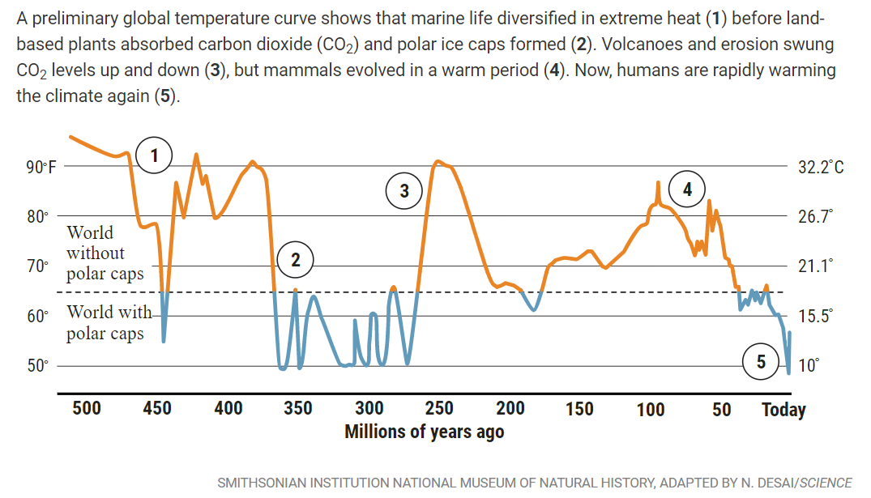
Variation in temperatures in the 20th century
Most warming took place in the 1930s and 1940s well before a significant increase in CO2 emissions. When CO2 increased from 1950, temperatures plummeted and scientists claimed an Ice Age was coming. Thereafter temperatures rose naturally from the 1980s but the increase was less than the increase experienced in the first half of the 20th century. Since 2000 temperatures have remained largely static. Most of the highest temperature records in the world (where good measurements exist) are from the 1930s and 1940s.
The diagram below is from page xxix of IPCC’s first report.
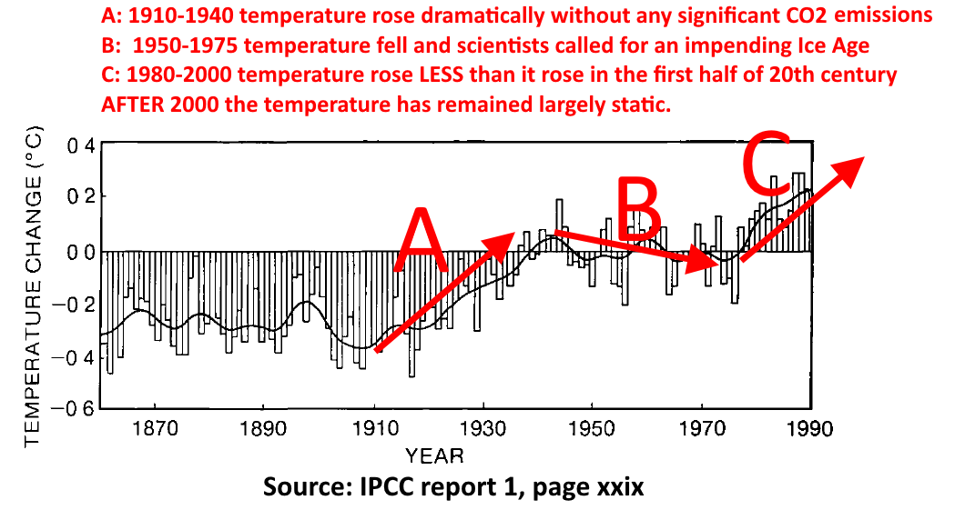
The only reliable surface temperature source confirms that temperatures have remained flat since 2005
Surface temperature measurements in the past decades have been badly contaminated by the urban heat island effect. So in January 2005, NOAA began recording temperatures at its newly built U.S. Climate Reference Network which includes 114 pristinely maintained temperature stations spaced relatively uniformly across the lower 48 states. These locations are far away from urban and land-development impacts that might artificially taint temperature readings. The diagram below shows that USCRN temperature stations show no warming since 2005. If anything, U.S. temperatures are now slightly cooler than they were 14 years ago. [Source]
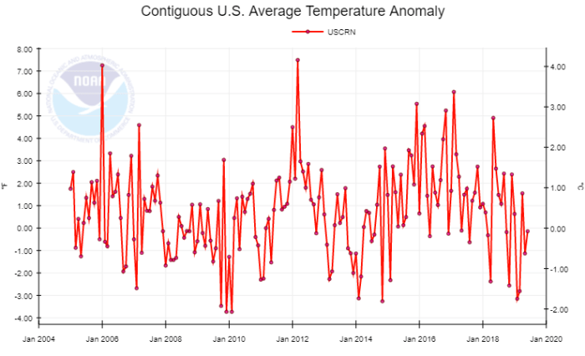
Temperatures from satellites – the other reliable source – also show little or no warming.
Climate predictions have all gone wrong
All climate predictions have failed. See this for a starting point – the full list would encompass many books.
Climate model predictions have dramatically over-shot reality.
The following diagram from a paper by John C. Fyfe, Nathan P. Gillett & Francis W. Zwiers in the prestigious Nature journal in 2013 demonstrates how badly the models have overshot. Further re-analyses have re-confirmed that 100+ models are consistently overshooting reality. (For more information see this.)
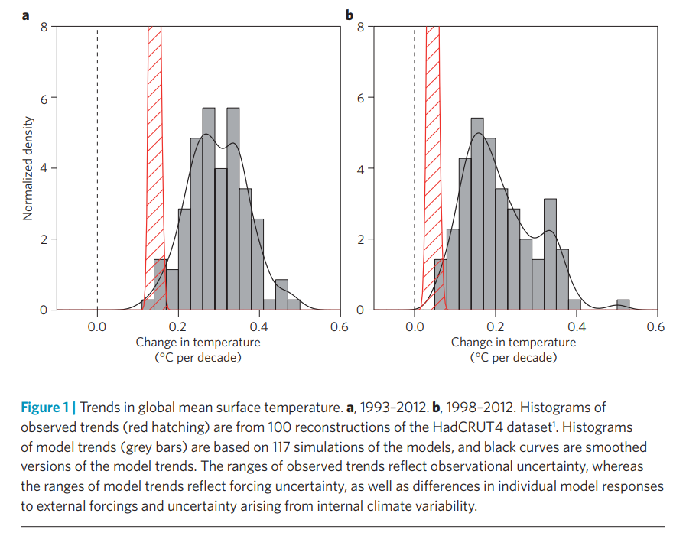
SEA LEVEL HAS BEEN INCREASING FOR THOUSANDS OF YEARS WITHOUT ANY EVIDENCE OF ACCELERATION
Sea levels are rising slowly for the past 200 years, without any observed acceleration
IPCC’s confirmed this fact at page 266 of its first report. The tiny observed acceleration pointed out by IPCC over the past 200 years is because of the recovery of the Earth from the Little Ice Age.
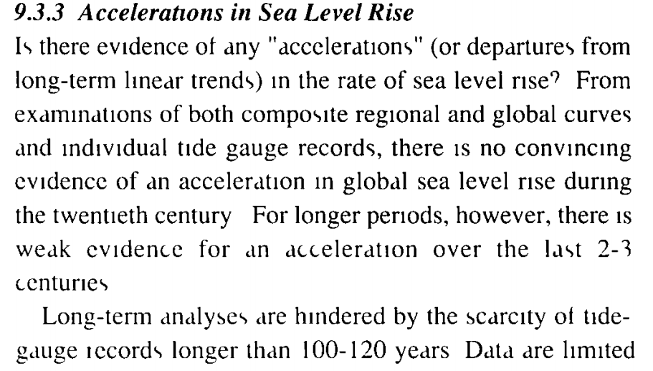
The longest NOAA tide gauge data record is at the Battery, New York with a 162 year long measurement period. This location shows no sea level rise acceleration occurring over the past 30 years. Similar results are seen from across the entire USA. [Source]. The key point is that the change in level might be different in different places but there is no accelerating trend in any place. See this video by Tony Heller from 6 minutes.
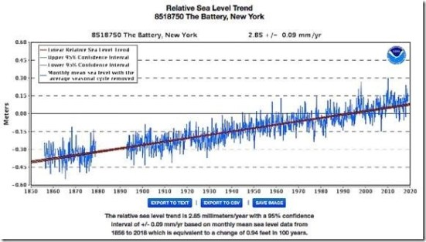
WHAT ABOUT OTHER QUESTIONS?
If there is no evidence of the “man-made” effect on temperature and sea levels. Therefore CO2 is NOT a problem. There is, instead, strong evidence that those who have been demonising CO2 come from the eugenicist, fascist, socialist and Malthusian stable. See evidence here.
There are many other questions about climate change. Many of them are addressed in articles, books and videos linked at http://swarnabharat.in/climate.
An introduction to key questions is provided below.
1. Is there no greenhouse gas effect?
The greenhouse gas effect is a proven hypothesis but its magnitude cannot be proven or understood in complex systems like the earth. Imagine 10,000 buckets of water. The CO2 volume in the air prior to 1950 was 3 buckets. Now it is 4 buckets. Total increase by man is 1 bucket. To assume that this miniscule increase would have a major effect is fundamentally misplaced. Such a theory is reminiscent of the theory of homeopathy. The world does not work that way. Since CO2 is plant food, the tiny increase in CO2 in the air is a boon for plants, forests and wildlife.
2. What about hurricanes (cyclones)?
There is no evidence of any increase. Chapter 3 of IPCC’s SR15 report published on 8 October 2018 confirms that “Such contradictions, in combination with the fact that the almost four-decade-long period of remotely sensed observations remains relatively short to distinguish anthropogenically induced trends from decadal and multi-decadal variability, implies that there is only low confidence regarding changes in global tropical cyclone numbers under global warming over the last four decades.”
3. What about glaciers?
The IPCC had the great embarrassment in 2009 of retracting its major false claim that Himalayan glaciers will disappear by 2035 (see this). Recently the Glacier National Park officials (in Montana, USA) had the intense embarrassment of pulling down a signboard which told visitors that the Park’s glaciers were all expected to disappear by either 2020 or 2030 (see this). Instead, some glaciers are growing (see this list). Glaciers are affected by local factors and there is no evidence of any accelerating trend of glaciers disappearing from Earth.
What about droughts? What about polar ice cap? What about Greenland? We encourage the reader to ask these and other such questions and to study climate science to address these questions. There is definite evidence of deforestation and its impacts but there is only evidence of a net positive effect of CO2 on the climate and environment. So our party does not support attempts by fascist eugenicist Malthusians who have captured the United Nations to restrict energy for India. India must use the cheapest form of energy.
ISSUED ON 26 SEPTEMBER 2019.
THE PEOPLE OF INDIA SHOULD LOOK FOR THEMSELVES AT THE TRUE FACTS.
HYSTERICAL CLIMATE ALARMISTS ARE PUTTING OUT A LOT OF FALSE INFORMATION TODAY.
Visit: http://swarnabharat.in/climate
JOIN SWARNA BHARAT PARTY TO FIGHT THE ANTI-SCIENCE SOCIALISTS.

